CSA5103 – Cryptography and Network Security
Lab Experiments

Name: K. Teja Sri
Register No: 192525249

Exp.No:4

4. Write a C program for polyalphabetic substitution cipher uses a separate monoalphabetic substitution cipher for each successive letter of plaintext, depending on a key.

Aim:
To implement the Polyalphabetic Substitution Cipher (Vigenère Cipher) using Python. In this cipher, multiple Caesar ciphers are used based on a repeating keyword.

Algorithm:
- Read the plaintext.
- Read the keyword.
- Repeat the keyword until it matches the plaintext length.
- Convert letters to numbers (A=0, B=1, ..., Z=25).
- Encrypt each character using:
$$C=\left(P+K\right) 26$$
- Convert the encrypted numbers back to letters.
- Display the ciphertext.

Program:
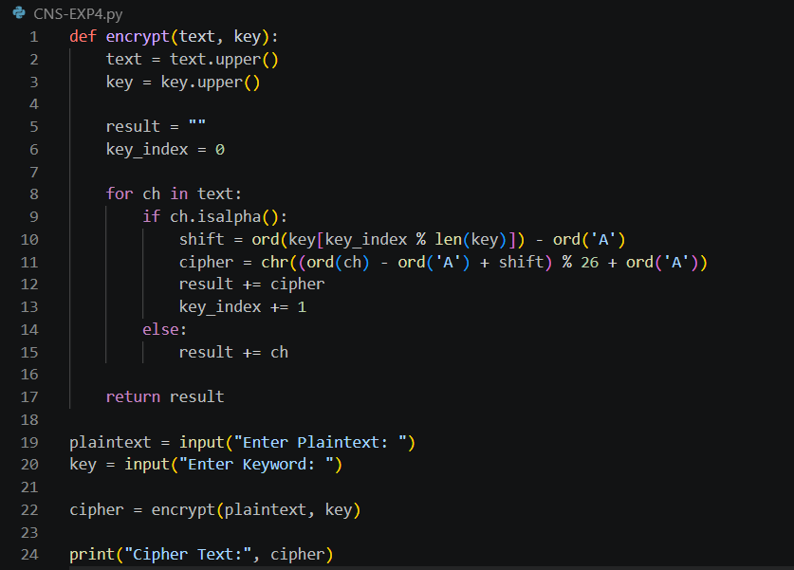

Output:
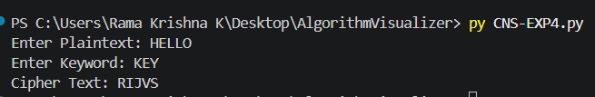

Result:
Thus, the Polyalphabetic Substitution Cipher (Vigenère Cipher) was successfully implemented in Python, and the plaintext was encrypted using a repeating keyword.

